Bash scripting: -
created test file.
provided full permissions
Tested with the same commands as shown in video.
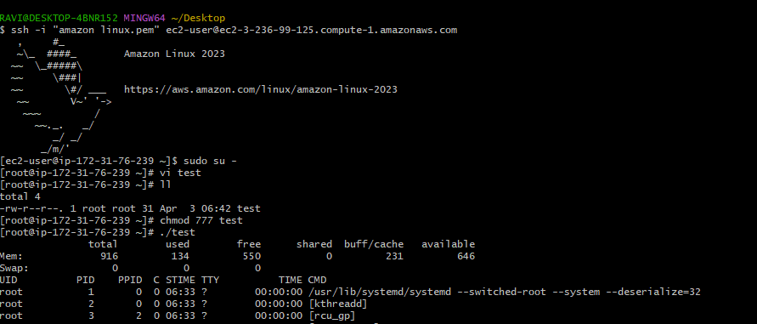

Used the same commands shown in video:-
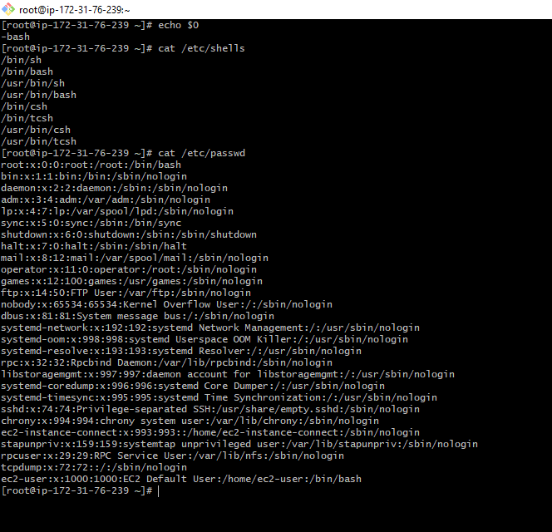

Changed the bash scripting and then created a new directory and file and then followed commands
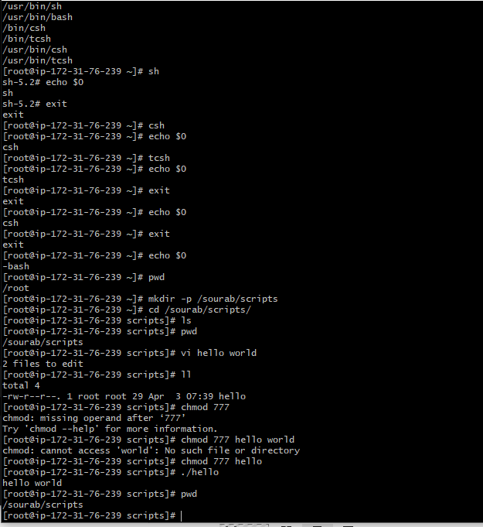
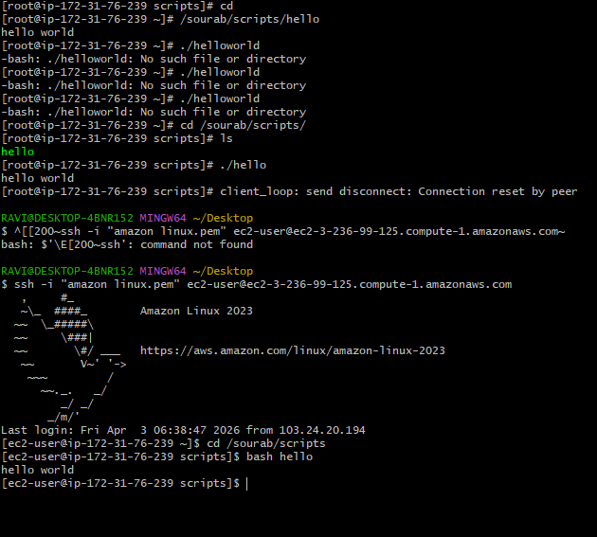

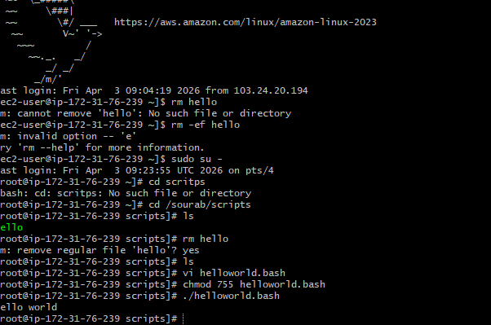
Defining Tasks

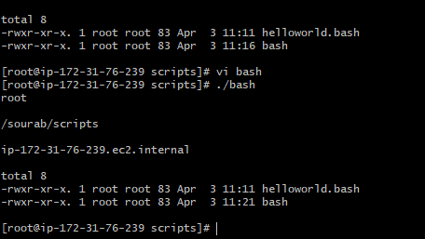

Defining variables
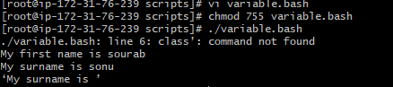
Read Input
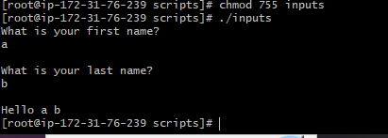
Scripts to run commands within
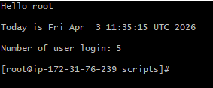
Read input and perform a task
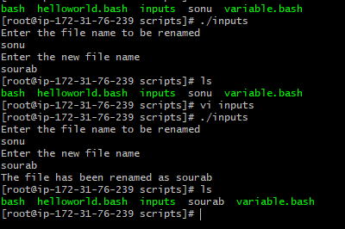

case Scripts:
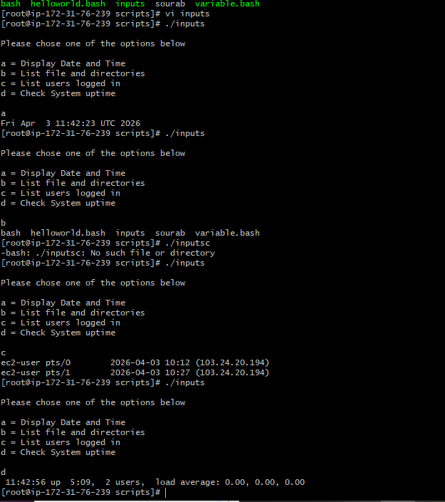

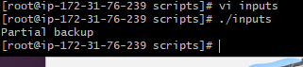
Script to run for a number of times
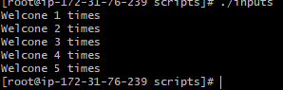
Script to run for a number of seconds
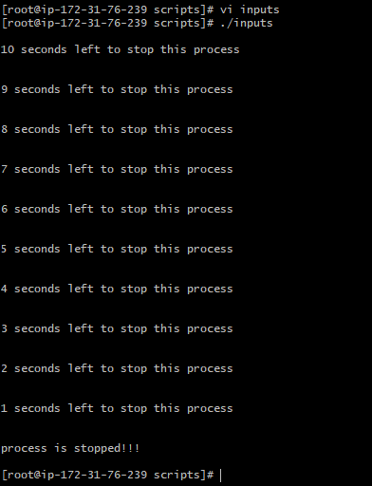
Simple for loop output
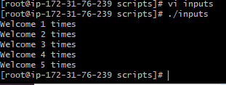

for loop to create 5 files named 1-5
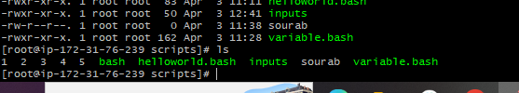
for loop to delete 5 files named 1-5
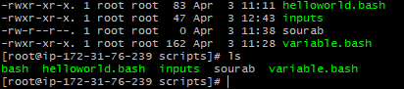
Specify days in for loop
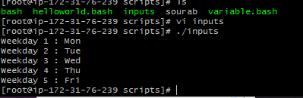

List all users one by one from /etc/passwd file
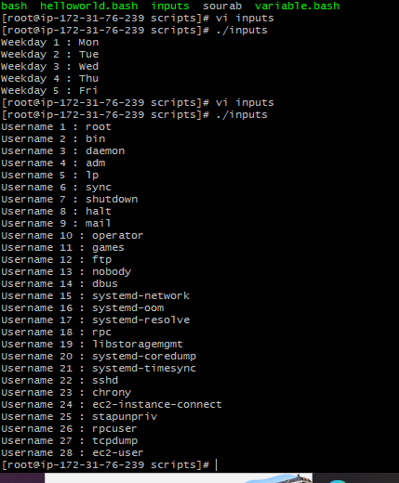
Check the variable
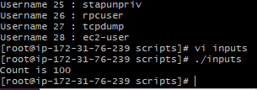
Check if a file error.txt exist
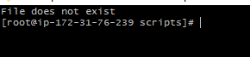

Check if a variable value is met
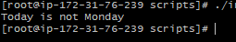

Check the response and then output
